RDBMS (Lab1_ANP_C7279_RDBMS_DDL)

Hareesha H M

AF0364330

Lab 1. Create a Database & Table Using MySQL Command-Line Client.

* Create a database with the name StudentManagementSystem.

Code:

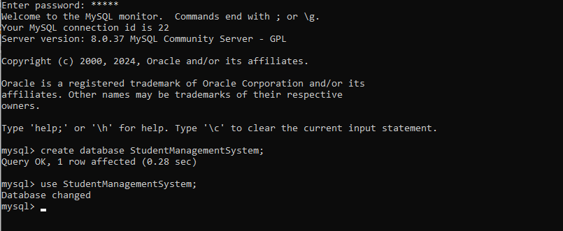

Output:

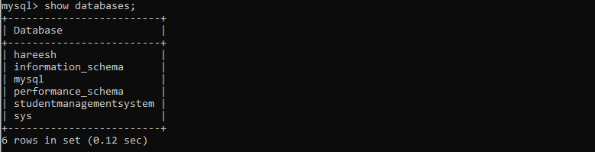

Create a table with named Student with attributes:

* StudentID (Primary Key)
* FirstName
* LastName
* DateOfBirth
* Gender
* Email

(

* Phone

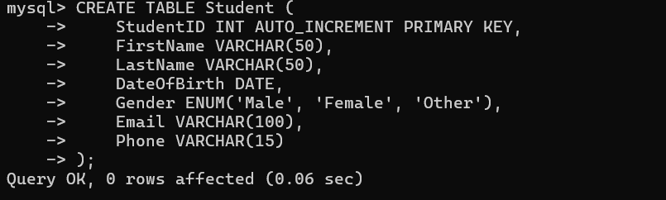Code:

Output:

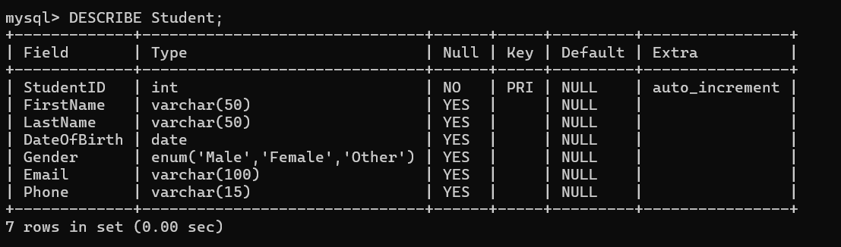

Create a table with name Course with attributes:

* CourseID (Primary Key)
* CourseTitle
* Credits

Code:

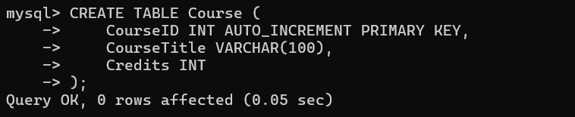

Output:

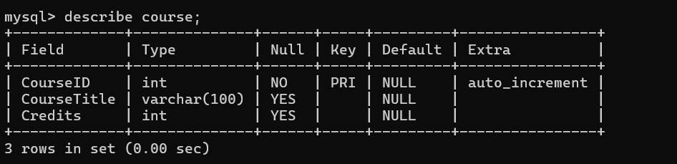

Create a table with named Instructor with attributes:

* InstructorID (Primary Key)
* FirstName
* LastName
* Email

Code:

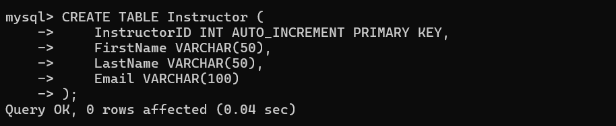

Output:

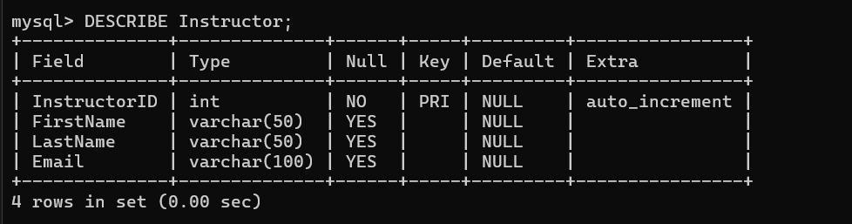

Create a table with named Enrollment with attributes:

* EnrollmentID (Primary Key)
* EnrollmentDate
* StudentID(Foreign key)
* CourseID(Foreign Key)
* InstructorID(Foreign key)

Code:

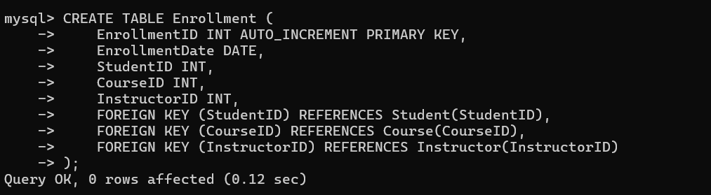

Output:

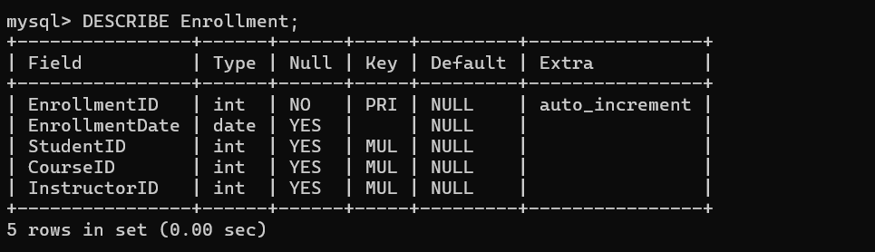

Create a table with named Score with attributes:

* ScoreID (Primary Key)
* CourseID (Foreign key)
* StudentID (Foreign Key)
* DateOfExam
* CreditObtained

Code:

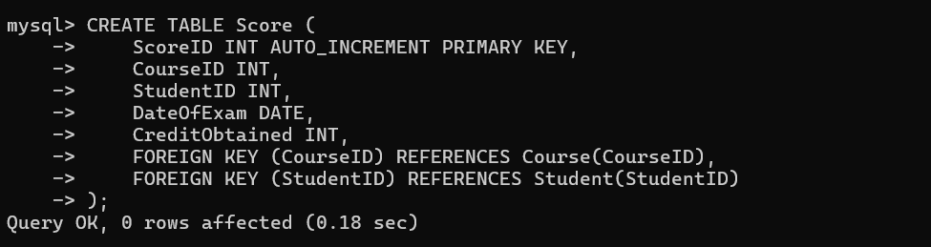

Output:

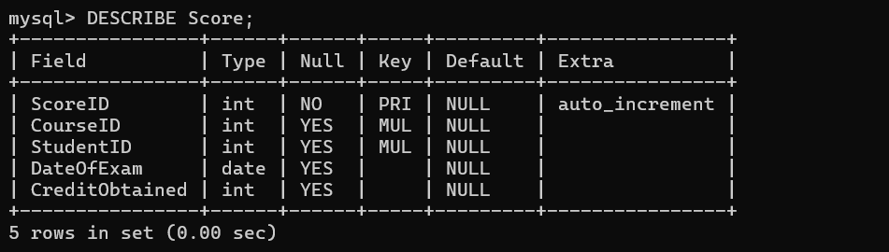

Create a table with named Feedback with attributes:

* FeedbackID (Primary Key)
* StudentID (Foreign key)
* Date
* InstructorName
* Feedback

Code:

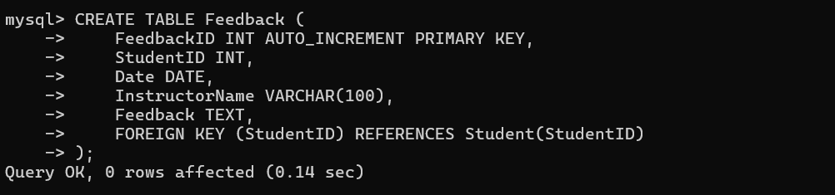

Output:

